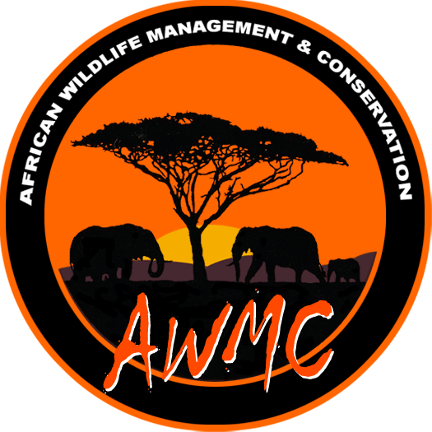
Voluntourism – Game Capture

A bit about us…
AWMC is a game capture team based in Harare, Zimbabwe. The team was established in 2006, in response to a need in the wildlife industry for an independent operator, capable of translocating large numbers of varied species of animals.

Since its inception, the company has successfully relocated and managed thousands of animals under difficult circumstances in turbulent Zimbabwe. AWMC is also one of the few capture teams in southern Africa with the capability of moving entire herds of elephant.

The strength of the company is its people, and both the directors and employees have been in the wildlife management industry for some time, and have collectively built up a large amount of experience in the field. AWMC is a small family-owned business and we believe that good relationships are the key to success, with our employees, our clients, and stake-holders in the industry.

We believe in conservation through the sustainable utilization of wildlife, and we recognize that for this to work, wildlife must have a value. We aim to add value in our services, preserve wildlife and its environment, and educate people as to the importance, value and relevance of wild animals.
To this end we work closely with stake-holders in the industry, including the Zimbabwe Parks and Wildlife Management Authority. We do not condone cruelty to animals, and we are continuously looking for ways to relocate game more effectively with less stress and minimum mortalities.

Now, for the first time, AWMC is inviting you to join us for a few weeks in order that you may experience first-hand what it means to be in this specialized area of wildlife conservation and management, and at the same time get to see some of the sites and people of Zimbabwe, from an angle not normally seen by the average tourist.

Who is this for?
Anyone with a taste for adventure and excitement, who wants to get involved hands-on in a wildlife project that is real. You must be relatively fit, a keen worker, eager to learn, and willing to have some fun.

What does it involve?
Joining the team in Zimbabwe, travelling and working with them on their actual jobs.
The work is physical and demanding at times, often in rough conditions, but also very rewarding. You may also get a chance to work with some wildlife vets who are involved with various projects including rhino monitoring and lion darting for testing of diseases.

What is the optimum time to spend with the team?
We recommend 2 – 4 weeks, to benefit from the variety that we have to offer. However we also offer short (1 -2 days) stays that are project-based and will be focused on a specific translocation.

Is it dangerous?
The short answer is – yes. However, if you follow instructions carefully, don’t do anything silly, and use common sense, you will be fine. Accidents happen in all occupations, and ours is no exception, but the people you will be working with have learnt how to avoid the sharp and sore ends of the animals.
Game Capture is exceptionally fun and rewarding, but the reality is that there are risks involved – both to you the capturer, and the animals being caught. You will need full medical aid cover, which includes repatriation, and will have to sign an indemnity form.

What would a typical day be like?
A typical day will consist of the following:

- Early rise – dawn or before- coffee and rusks.
- Pack vehicles with equipment needed for the day’s job:
Dart- gun, Drugs, Radios, Water, Sleigh/stretcher, Ropes, Prodders, Blind-folds etc.
- Travel to Capture Site
- Briefing on day’s work
- Assist with capture operation, which may be one of the following, and the duties may be varied, depending on the situation:
- Darting – usually individual animals. Duties: to assist the team with the operation, may include chasing animal with ropes, care of the animal once it is immobilized, assist with monitoring of the animal, help loading, take samples, temperature control, record-keeping etc.
- Net Boma – usually impala. Duties: to assist with the capture and restraint of the animals, as instructed in the briefing, care, management and monitoring, loading etc.
- Plastic Boma – usually larger numbers of animals. Duties: to assist with running curtains, pushing with a push-board / plastic, loading, monitoring, record-keeping etc.
- Building of Bomas in preparation for captures – you will learn about boma-siting, the importance of wind direction, the different behaviours of different species in the capture situation etc. Duties: assist with physical work involved with boma construction as instructed.
- Assist with game-spotting from the helicopter.
- Travel with delivery vehicle to assist with monitoring of animals and offloading at destination.

- Breakfast and review
- Continue with the day’s work
- Lunch and review
- Continue with capture program
- Debriefing and questions.
- Pack up and cleaning of equipment
- Return to base for preparation of next job
- Dinner

What will accommodation be like?
Accommodation will vary – from simple game lodges to camping in tents. It will not be luxury, just functional. You may need sleeping bags at times. You will basically stay with the capture team, and they have learnt to be prepared for anything!

Food?
Food will be simple, and cooked by either ourselves, or a camp attendee. Coffee and biscuits/rusks will be available when we wake up, followed by a cooked breakfast mid-morning. Lunch is usually light and cold, with snacks, biscuits and fruit available in the afternoons. The main meal will be dinner.

Do I need any special equipment?
You just need yourself and a good attitude. However, the following may also help:

- 4-5 sets of clothing, khaki/pastel colours, (no bright whites).
- 2 pairs of comfortable outdoor shoes.
- Cap/hat.
- Sun-block.
- Anti-malarial tablets.
- Insect repellant.
- Toiletries.
- Sleeping bag.
- A camera would be a good idea to record all those memorable moments.

What does it cost?
US $995.00 per week, although shorter trips will be charged differently, depending on the situation; please contact us for a quote for short trips. This price includes accommodation, meals, transport (except air tickets), tea/coffee and juice. Beers will be available in the evenings from a cash bar.
This money will go directly to operating costs of the company, and will also be used to supplement the cost of treatment of sick, snared or injured animals that would otherwise not be treated.

What will I get out of it?
A unique certificate of participation, some great photos, a wonderful experience, and the knowledge that you have contributed to conservation in Africa. You will have met some great people, been to some stunning places, and generally had a safari like no other.

What am I waiting for?
We don’t know. Contact us at nicksar@zol.co.zw or via our website at www.awmc.biz

This document has been produced by AWMC, Zimbabwe and serves as an informal guide only. This document provides no guarantees whatsoever to the content presented in any shape or form. AWMC will not be held responsible for any misuse of the information provided in this document. This information was last updated in 2010.

